MODE SETTING | MENU START | 
MODE SETTING | MENU END | 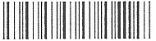
MODE SETTING | FACTORY DEFAULT | 

SCANNING  CODES | POS | * Enable | 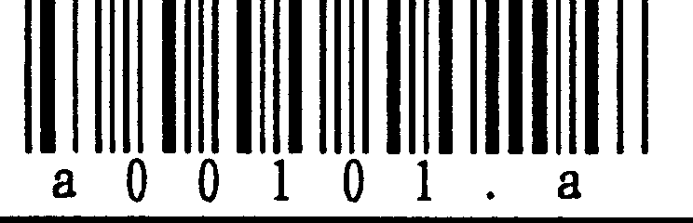
SCANNING  CODES | POS | Disable | 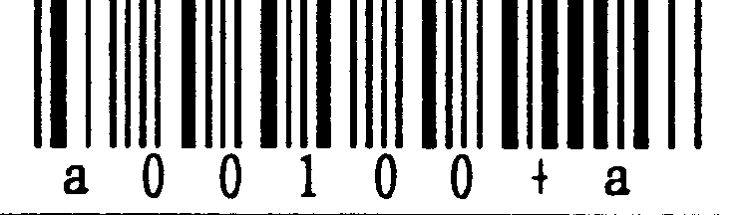
SCANNING  CODES | CODE 128 | Enable | 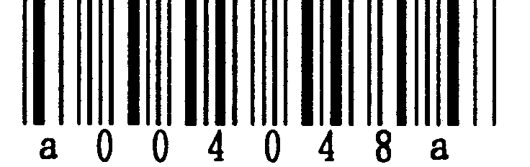
SCANNING  CODES | CODE 128 | * Disable | 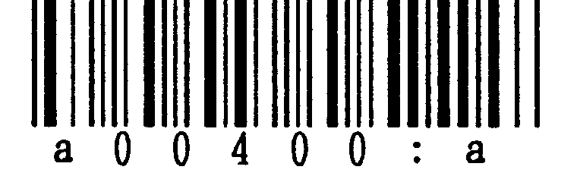
SCANNING  CODES | DOUBLE TOUCH | Enable | 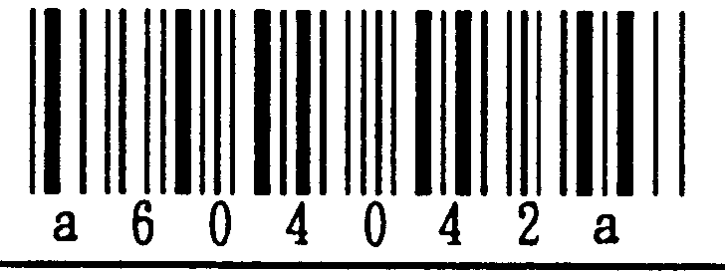
SCANNING  CODES | DOUBLE TOUCH | * Disable | 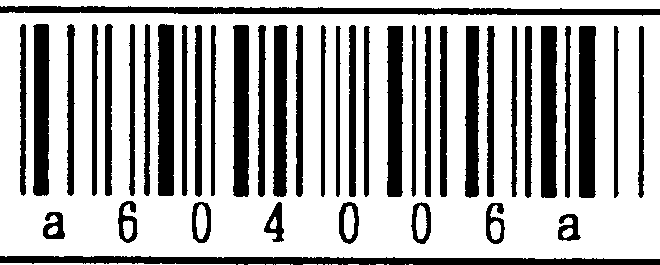
SCANNING  CODES | ITF | * W/out CD Enable | 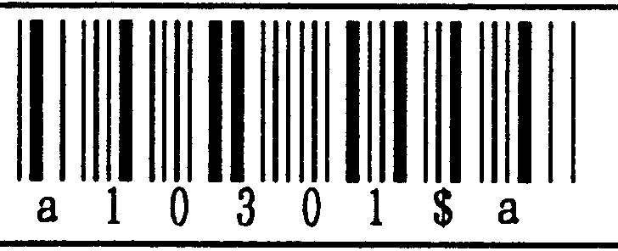
SCANNING  CODES | ITF | With CD Enable | 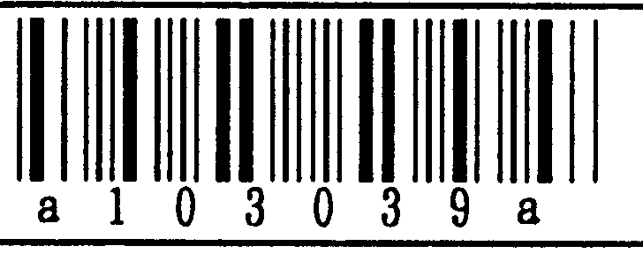
SCANNING  CODES | ITF | Disable | 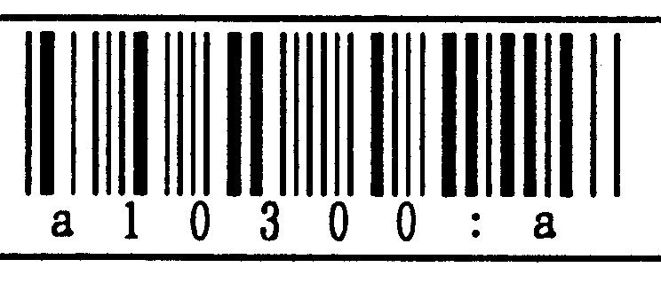
SCANNING  CODES | STF | * W/out CD Enable | 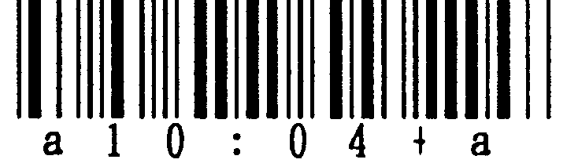
SCANNING  CODES | STF | With CD Enable | 
SCANNING  CODES | STF | Disable | 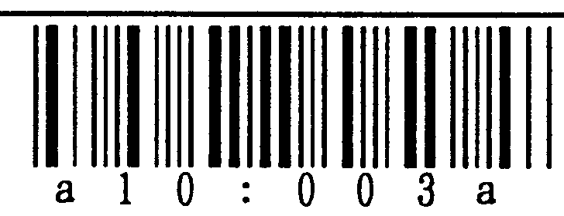
SCANNING  CODES | CODABAR | * W/out CD Enable | 
SCANNING  CODES | CODABAR | With CD Enable | 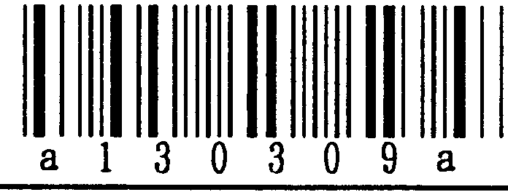
SCANNING  CODES | CODABAR | Disable | 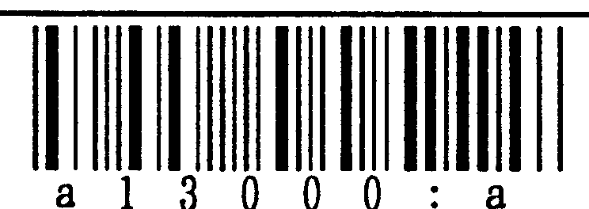
 | CODE 39 | * W/out CD Enable | 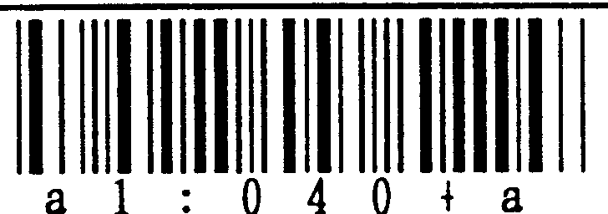
 | CODE 39 | With CD Enable | 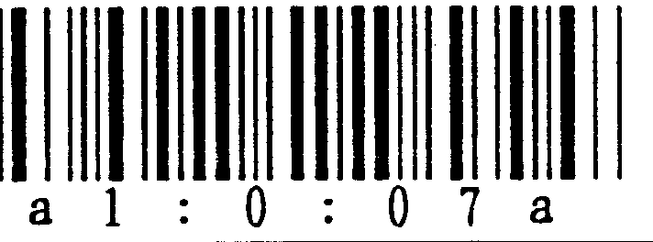
 | CODE 39 | Disable | 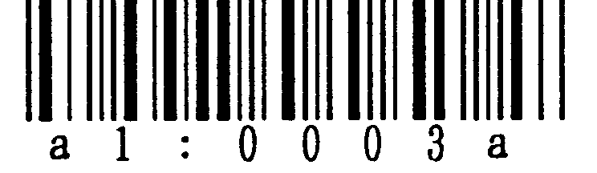

DATA  TRANSMISSION  FORMAT SELECTIONS | CODE MARK  TRANSMISSION | * Enable | 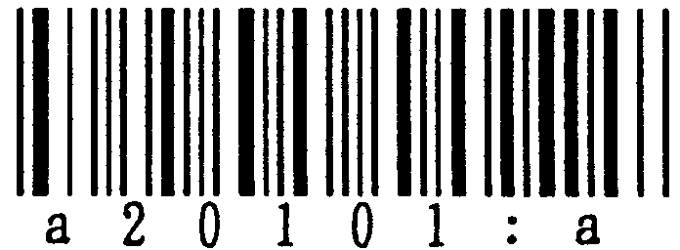
DATA  TRANSMISSION  FORMAT SELECTIONS | CODE MARK  TRANSMISSION | Disable | 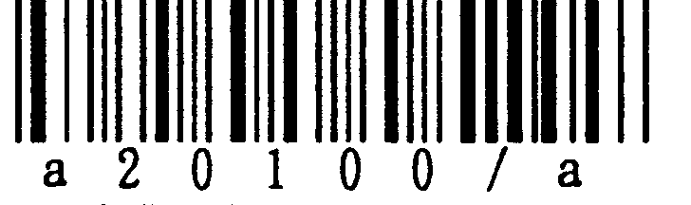
DATA  TRANSMISSION  FORMAT SELECTIONS | NUMBER OF  DIGITS TRANSMISSION  EXCLUDING  UPC/EAN CODES | * Enable | 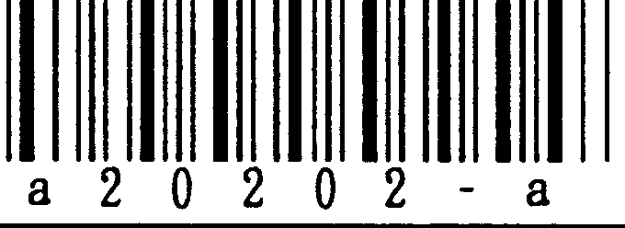
DATA  TRANSMISSION  FORMAT SELECTIONS | NUMBER OF  DIGITS TRANSMISSION  EXCLUDING  UPC/EAN CODES | Disable | 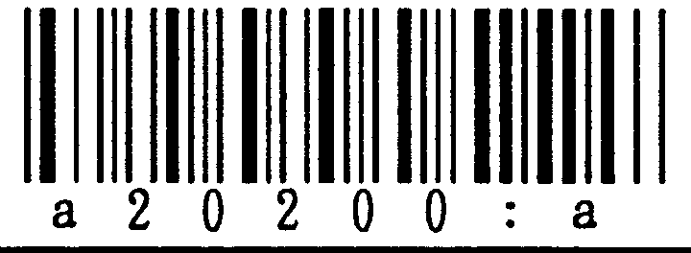
DATA  TRANSMISSION  FORMAT SELECTIONS | CODABAR  START-STOP  CHARACTERS | * Small Characters  a/b/c/d | 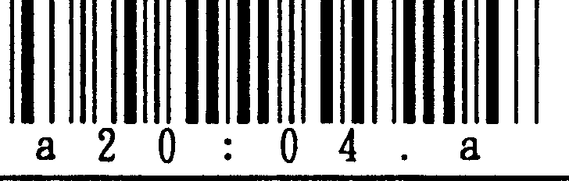
DATA  TRANSMISSION  FORMAT SELECTIONS | CODABAR  START-STOP  CHARACTERS | Capital Characters  A/B/C/D | 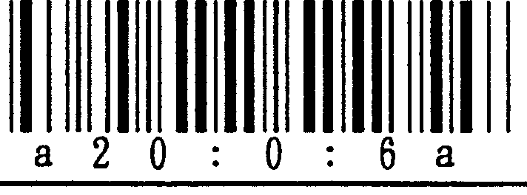
DATA  TRANSMISSION  FORMAT SELECTIONS | CODABAR  START-STOP  CHARACTERS | Disable | 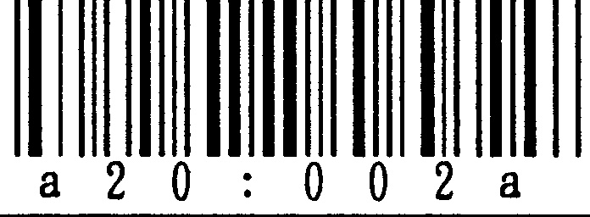
DATA  TRANSMISSION  FORMAT SELECTIONS | CODE39  START – STOP  CHARACTERS | Enable | 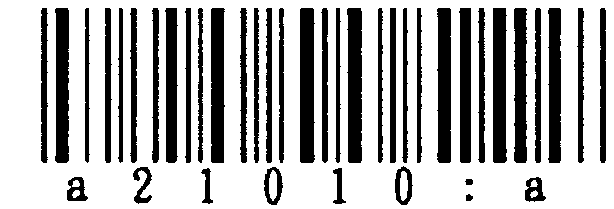
DATA  TRANSMISSION  FORMAT SELECTIONS | CODE39  START – STOP  CHARACTERS | * Disable | 
DATA  TRANSMISSION  FORMAT SELECTIONS | UPC-A ‘0’ TRANSM.  TO ADJUST NUMBER OF DIGITS OF  UPC-A CODE | * Enable | 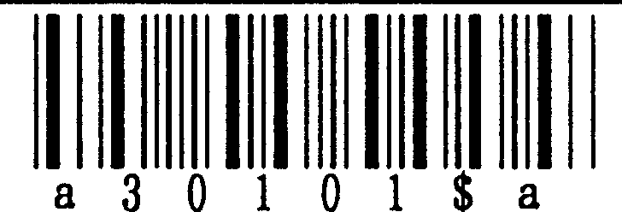
DATA  TRANSMISSION  FORMAT SELECTIONS | UPC-A ‘0’ TRANSM.  TO ADJUST NUMBER OF DIGITS OF  UPC-A CODE | Disable | 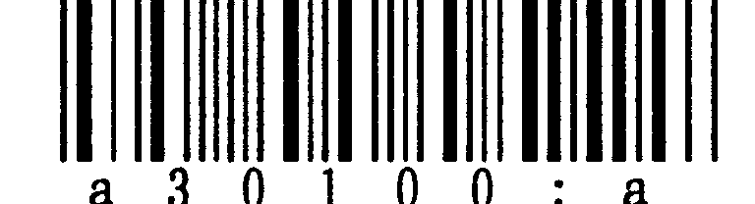
DATA  TRANSMISSION  FORMAT SELECTIONS | UPC-E ‘0’ TRANSM.  TO ADJUST NUMBER OF DIGITS OF  UPC-E CODE | Enable | 
DATA  TRANSMISSION  FORMAT SELECTIONS | UPC-E ‘0’ TRANSM.  TO ADJUST NUMBER OF DIGITS OF  UPC-E CODE | * Disable | 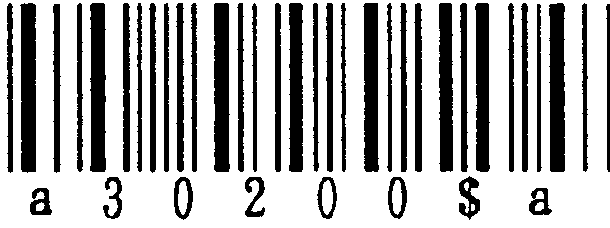
DATA  TRANSMISSION  FORMAT SELECTIONS | UPC-A CHECK DIGIT TRANSMISSION | * Enable | 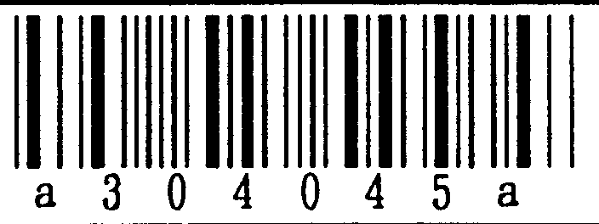
DATA  TRANSMISSION  FORMAT SELECTIONS | UPC-A CHECK DIGIT TRANSMISSION | Disable | 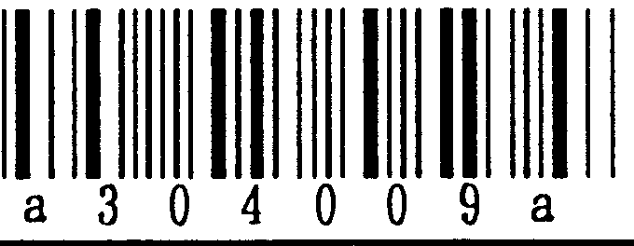

DATA  TRANSMISSION  FORMAT SELECTIONS | UPC-E-CD | * Enable | 
DATA  TRANSMISSION  FORMAT SELECTIONS | UPC-E-CD | Disable | 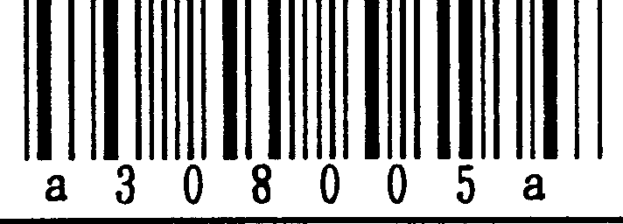
DATA  TRANSMISSION  FORMAT SELECTIONS | UPC-E Transmit Format | * 0 Suppress | 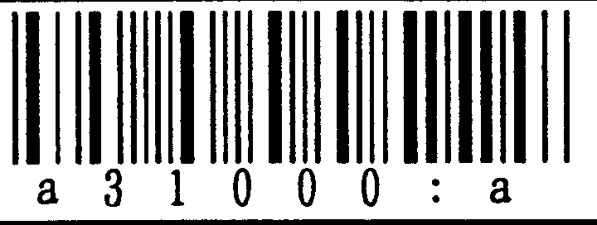
DATA  TRANSMISSION  FORMAT SELECTIONS | UPC-E Transmit Format | 0 Insert | 
DATA  TRANSMISSION  FORMAT SELECTIONS | POS CODE MARK | * A/C/A/B | 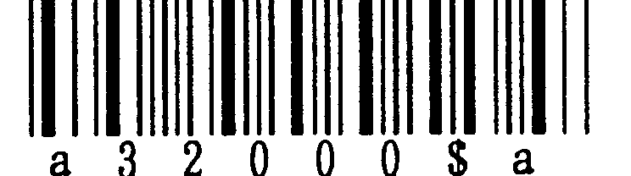
DATA  TRANSMISSION  FORMAT SELECTIONS | POS CODE MARK | A/E/F/FF | 

BUZZER, LIGHT LED INDICATOR LED | Buzzer | * Enable | 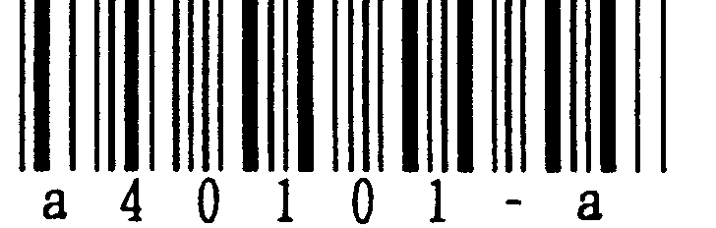
BUZZER, LIGHT LED INDICATOR LED | Buzzer | Disable | 
BUZZER, LIGHT LED INDICATOR LED | Indication Led | * Enable | 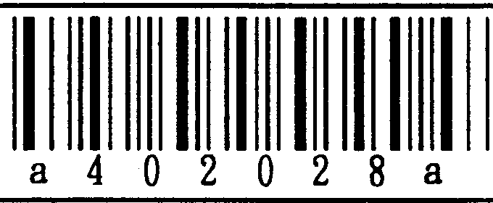
BUZZER, LIGHT LED INDICATOR LED | Indication Led | Disable | 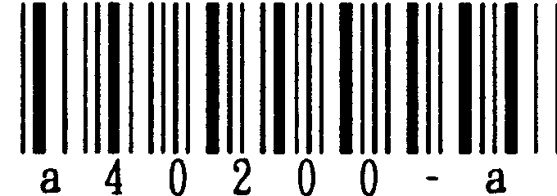
BUZZER, LIGHT LED INDICATOR LED | Timing of Buzzer and Led | * Before Transmission | 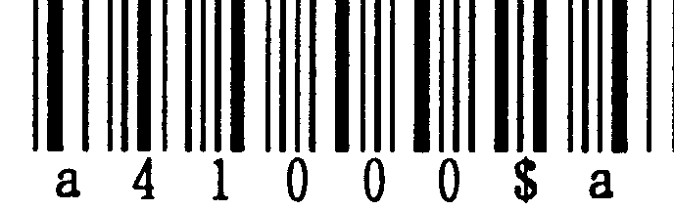
BUZZER, LIGHT LED INDICATOR LED | Timing of Buzzer and Led | After Transmission | 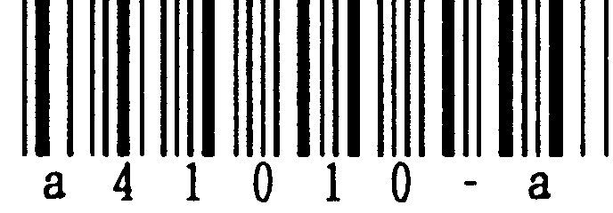

ASYNCHRONOUS | BAUD RATE | 1200bps | 
ASYNCHRONOUS | BAUD RATE | 2400bps | 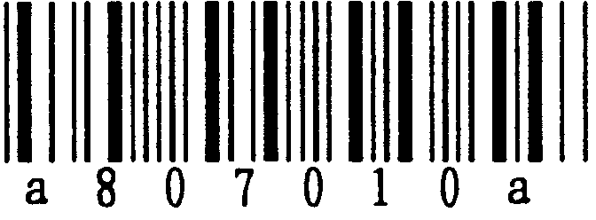
ASYNCHRONOUS | BAUD RATE | 4800bps | 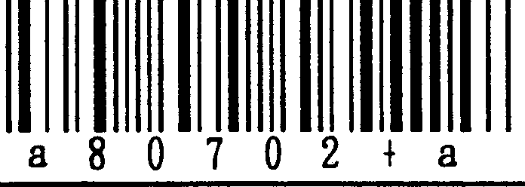
ASYNCHRONOUS | BAUD RATE | * 9600bps | 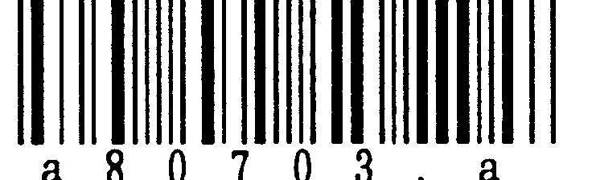
ASYNCHRONOUS | BAUD RATE | 19.2Kbps | 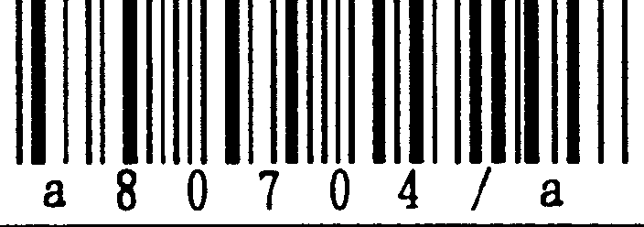
ASYNCHRONOUS | DATA LENGTH | 7 bits | 
ASYNCHRONOUS | DATA LENGTH | * 8 bits | 
ASYNCHRONOUS | PARITY | * NONE | 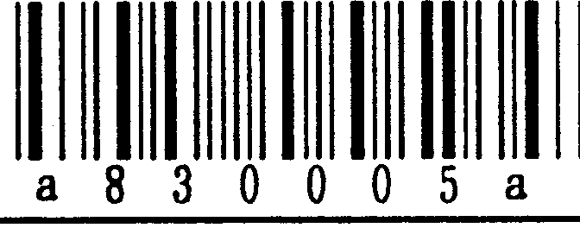
ASYNCHRONOUS | PARITY | EVEN | 
ASYNCHRONOUS | PARITY | ODD | 
ASYNCHRONOUS | STOP BIT | * 1bit | 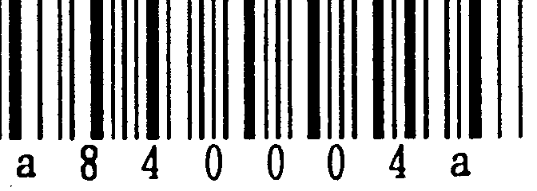
ASYNCHRONOUS | STOP BIT | 2 bits | 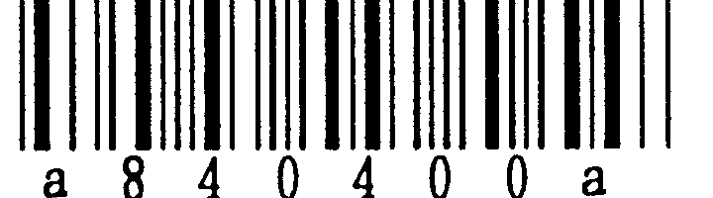
ASYNCHRONOUS | Communication Mode | * No Protocol | 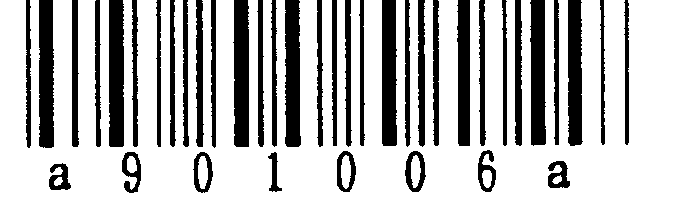
ASYNCHRONOUS | Communication Mode | ACK/NAK | 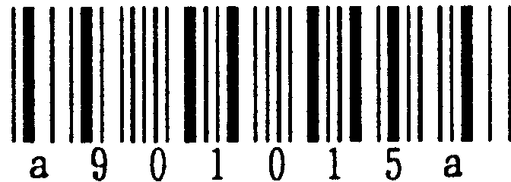
ASYNCHRONOUS | RTS Signal Control | * Scanner Ready | 
ASYNCHRONOUS | RTS Signal Control | Data Ready | 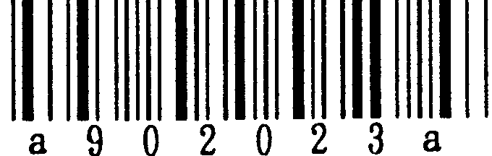

 | Command ‘Q’ at Initialization | * Disable | 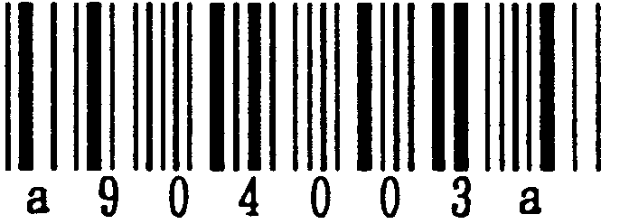
 | Command ‘Q’ at Initialization | Enable | 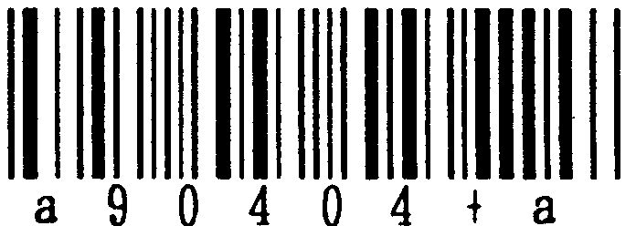
 | Header | * None | 
 | Header | STX | 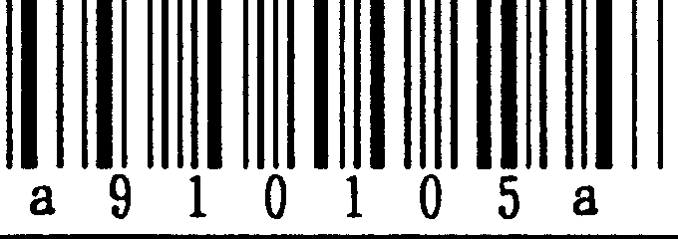
 | Terminator | ETX | 
 | Terminator | * CR | 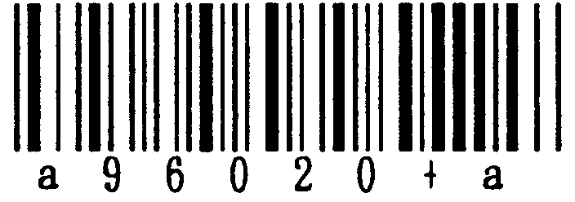
 | Terminator | LF | 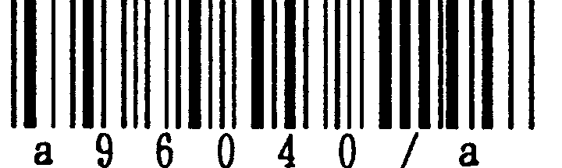
 | Terminator | CR-LF | 
 | CTS Signal Observation Time | 100mec | 
 | CTS Signal Observation Time | * 200msec | 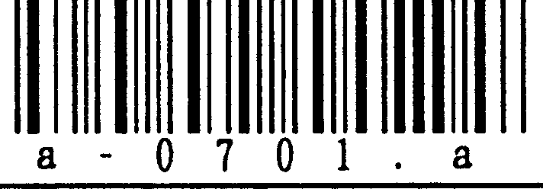
 | CTS Signal Observation Time | 500msec | 
 | CTS Signal Observation Time | 1sec | 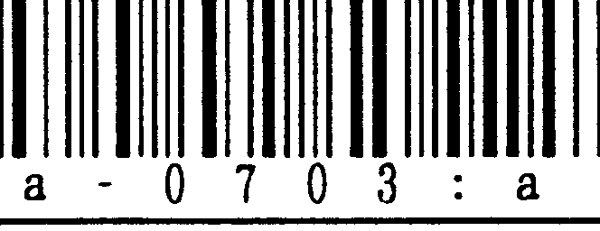
 | CTS Signal Observation Time | 2sec | 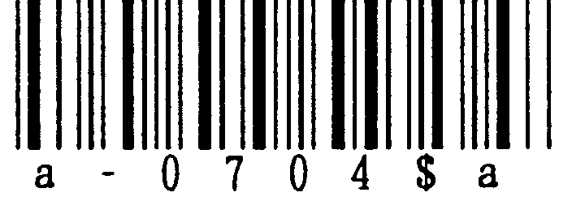
 | CTS Signal Observation Time | 5sec | 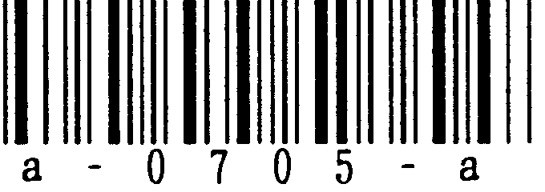
 | CTS Signal Observation Time | Infinite | 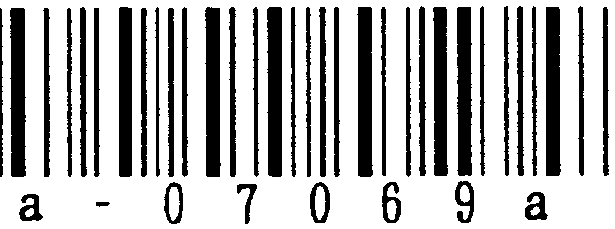

 | ACK/NAK Response Time | 100msec | 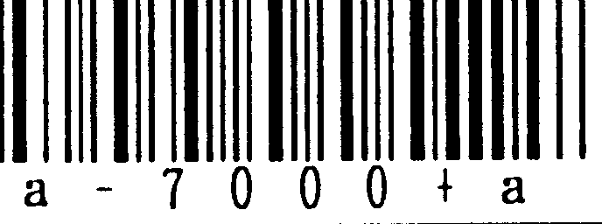
 | ACK/NAK Response Time | 200msec | 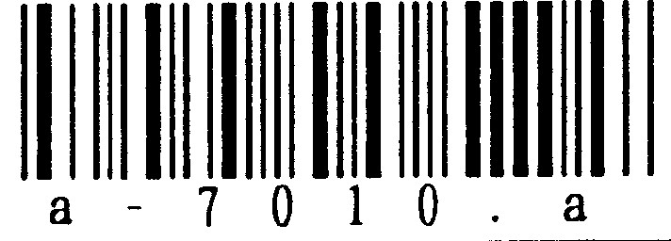
 | ACK/NAK Response Time | 500msec | 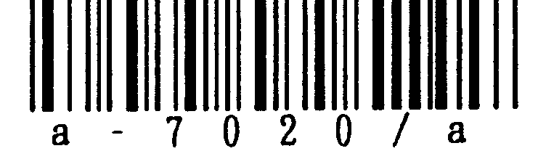
 | ACK/NAK Response Time | * 1sec | 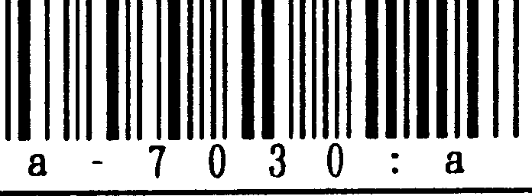
 | ACK/NAK Response Time | 2sec | 
 | ACK/NAK Response Time | 5sec | 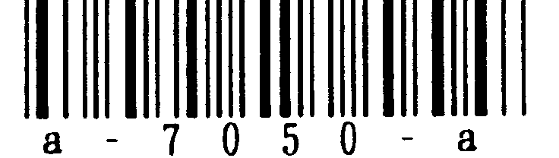
 | ACK/NAK Response Time | Infinite | 